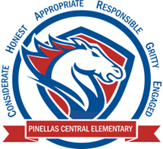

**Pinellas Central Elementary School**

**Kindergarten School Supply List 2024-2025**

**Student Items (for individual students use)**

* headphones or earbuds
* 4 plastic 2 pocket folders with prongs (red, yellow, green, and blue)
* 1 student’s choice folder for take home folder (fun design or favorite color)
* 2 boxes of crayons -16 count
* 6 glue sticks
* full size backpack (no wheels)
* no binders, and no tab dividers
* 2 boxes of yellow pencils
* erasers
* one pencil box for each child.
* one primary journal/composition notebook (writing lines and space for drawing)

**Supplemental Classroom Items – Donations Appreciated**

* tissues
* disinfecting wipes
* disinfecting spray
* hand sanitizer
* zip top plastic bags – sandwich or gallon size